32.13: a) 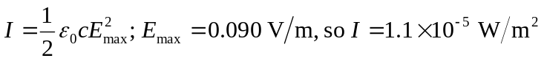
b)
c)
d) Calculation in part (c) assumes that the transmitter emits uniformly in all directions.

